**Lab Assignment 5**

**1. Shell Script to find GCD of given 2 numbers.**

**(Use While condition)**

**Program**

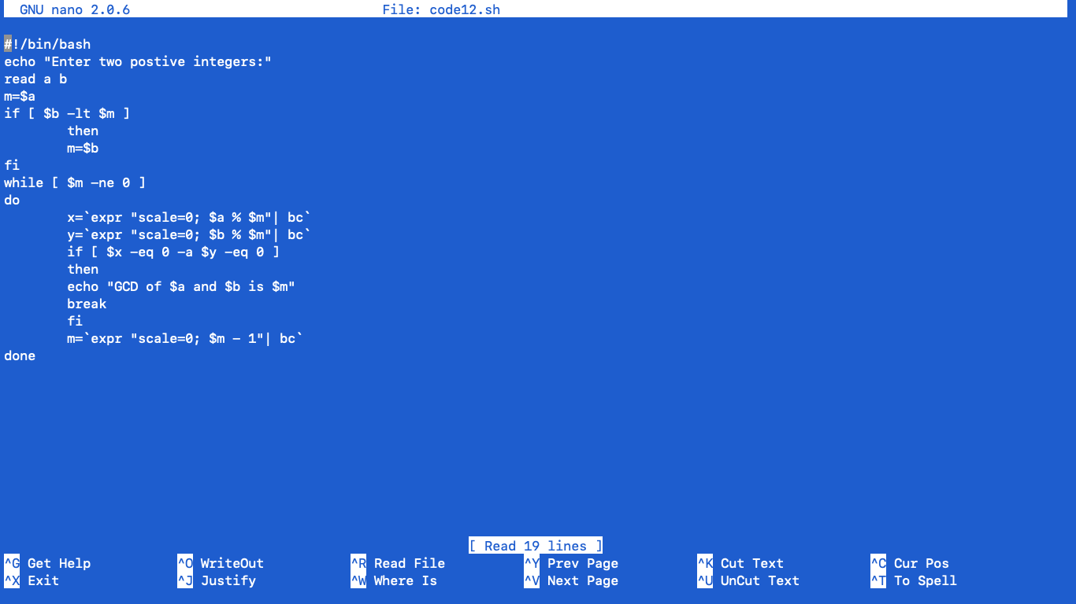

**Output**

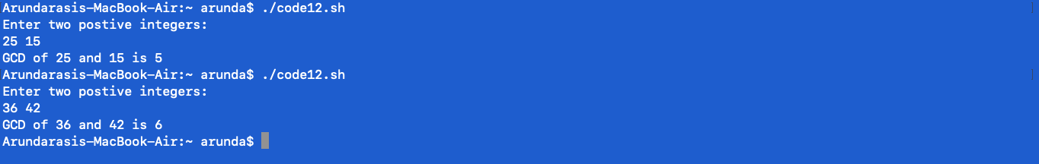

**2. Shell script to reverse any digit number given by the user.**

**(Use While condition).**

**Program**

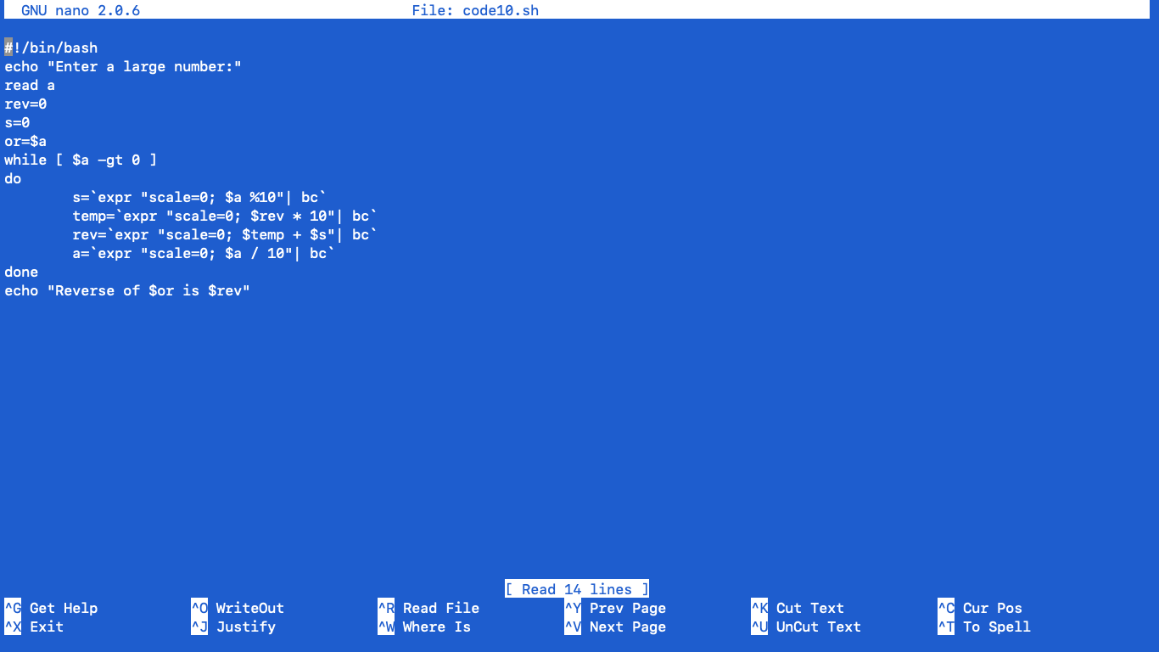

**Output**

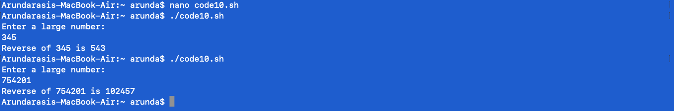

**3. Shell script to calculate factorial of the number. (Use FOR loop).**

**Program**

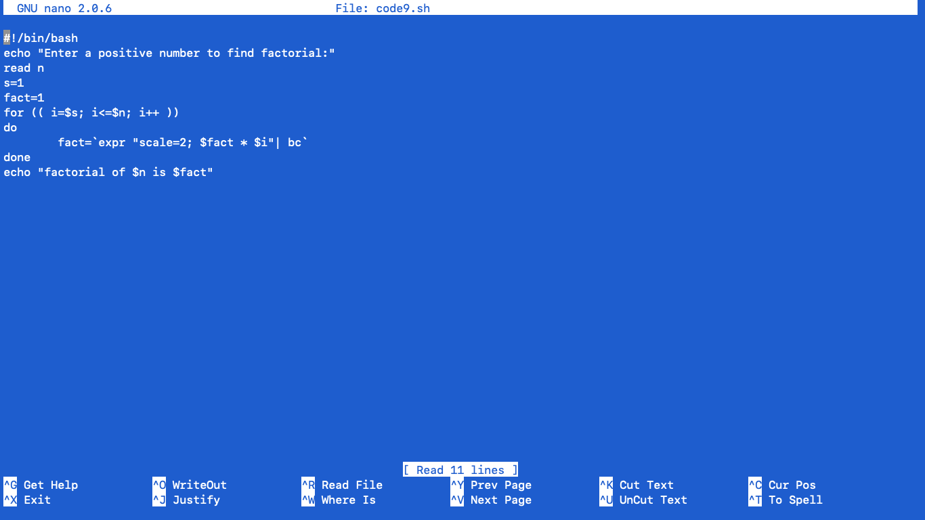

**Output**

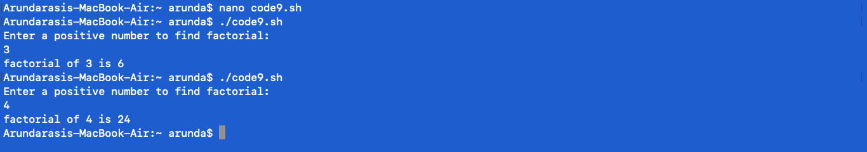

**4. Shell script to display elements of an array in sorted manner (asc or dsc).**

**(Use FOR loop).**

**Program**

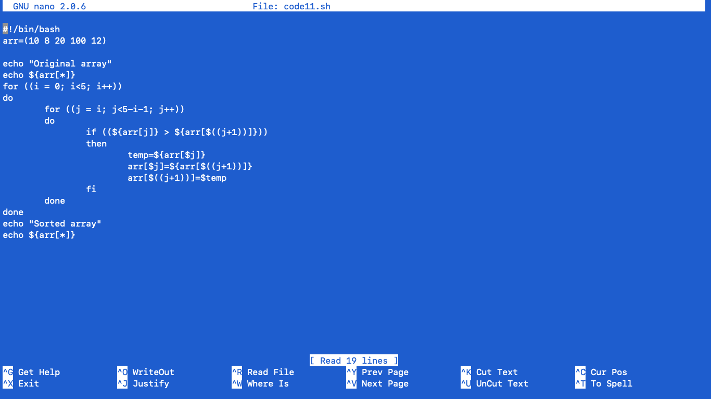

**Output**

